SETTING UP APPLICATION ENVIRONMENT

INSTALL IBM CLOUD CLI

|  |  |
| --- | --- |
| **DATE** | **24 OCT 2022** |
| **TEAM ID** | **PNT2022TMID53821** |
| **PROJECT NAME** | **SKILL AND JOB RECOMMENDER APPLICATION** |
| **TEAM MEMBERS** | **ARUMUGAPRIYA M**  **JAEL JESSICA A**  **JANISHA S**  **BERTENA R** |

# STEP 1

Login to your IBM Cloud [***https://cloud.ibm.com/login***](https://cloud.ibm.com/login) and in-search bar you can type

Container registryand click to get started.

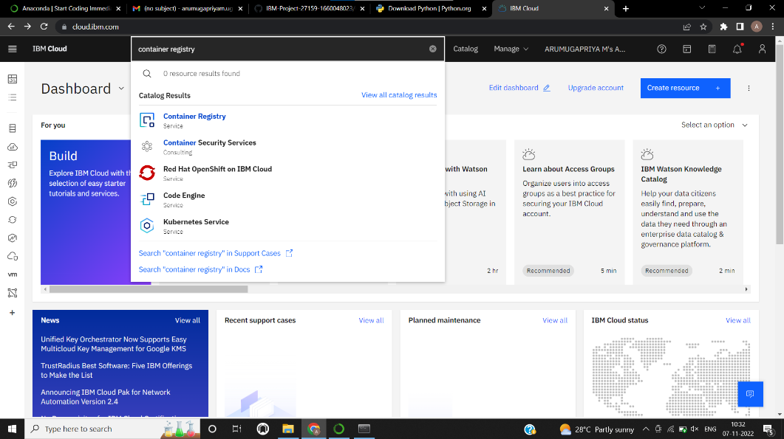

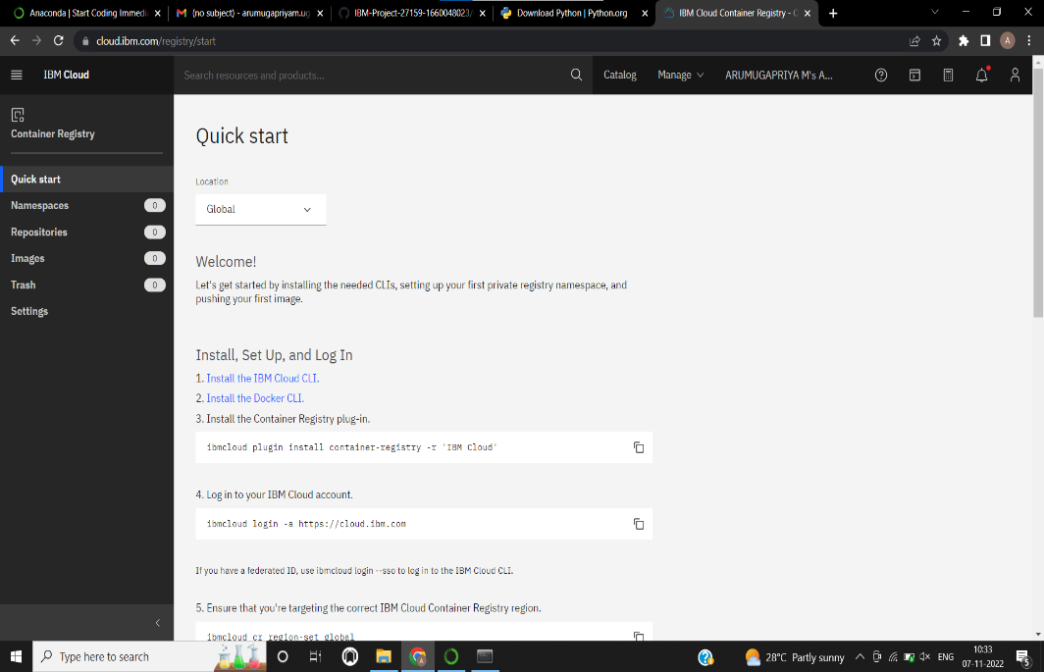

# STEP 2

Follow and do the step given in this page one by one [***https://cloud.ibm.com/registry/***](https://cloud.ibm.com/registry/%20start)

[start](https://cloud.ibm.com/registry/%20start)

# STEP 3

Run the command in power shell,

(New-Object Net.WebClient).DownloadString('https://clis.cloud.ibm.com

/install/powershell')

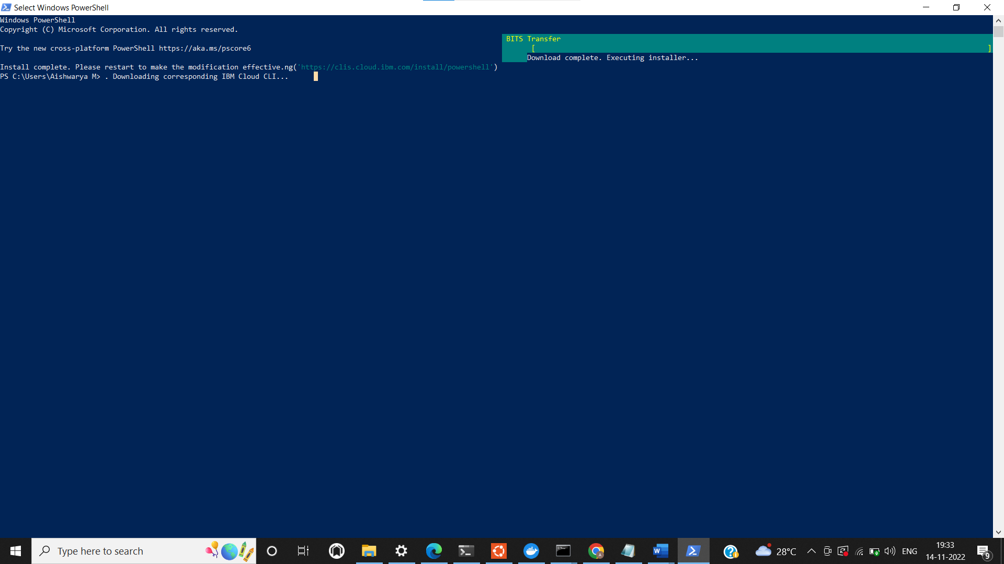

# STEP 4

Run all the command one by one in cmd

<https://cloud.ibm.com/docs/containers?topic=containers-cs_cli_install>

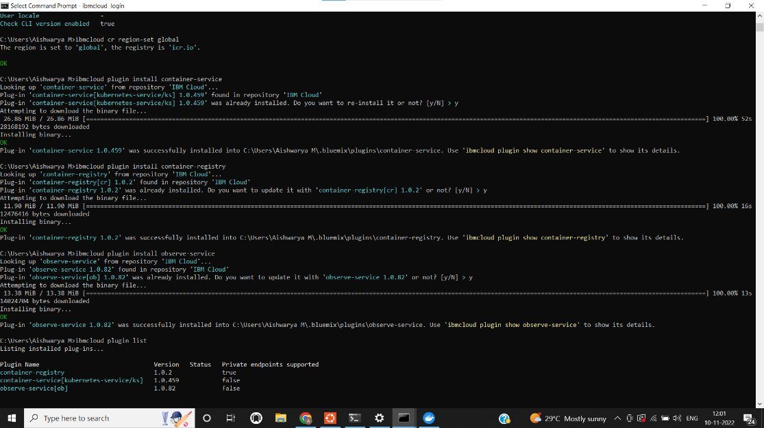

# STEP 6

Finally, you will get the IBM CLOUD CLI in your desktop